1) DDL Commands – CREATE, ALTER, DROP

CREATE DATABASE labdb;
USE labdb;

CREATE TABLE student2 (RegNo INT, SIName VARCHAR(15), Age CHAR(2), MobileNo INT, address VARCHAR(15));

ALTER TABLE student2 ADD PRIMARY KEY(RegNo);

DESC student2;

CREATE TABLE faculty (Facno INT, FName CHAR(15), gender CHAR(1), DOB DATE, MobileNo INT, address VARCHAR(20));

ALTER TABLE faculty ADD PRIMARY KEY(Facno);

ALTER TABLE faculty ADD CHECK (gender IN ('M','F'));

DESC faculty;

CREATE TABLE department (deptno INT, dname CHAR(15), loc CHAR(10));

ALTER TABLE department ADD PRIMARY KEY(deptno);

DESC department;

CREATE TABLE course (cno INT, cname VARCHAR(15), semno INT, facno INT);

ALTER TABLE course ADD PRIMARY KEY(cno);

ALTER TABLE course ADD CHECK (semno >=1 AND semno <=6);

DESC course;

ALTER TABLE student2 ADD UNIQUE KEY(SIName);

DESC student2;

ALTER TABLE student2 MODIFY address VARCHAR(15) NOT NULL;

DESC student2;

SHOW TABLES;

OUTPUT:

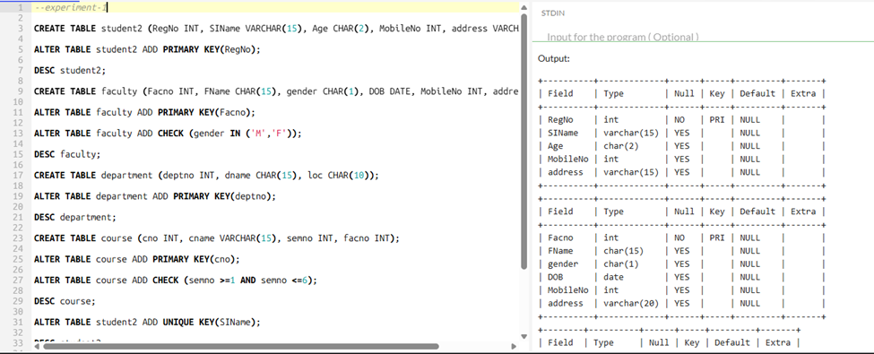

2)DDL Commands with Constraints – PRIMARY, FOREIGN KEY, UNIQUE, CHECK

CREATE DATABASE labdb2;
USE labdb2;

CREATE TABLE department (DeptNo INT PRIMARY KEY, DName VARCHAR(20) UNIQUE, Location VARCHAR(15));

DESC department;

CREATE TABLE faculty (FacNo INT PRIMARY KEY, FName VARCHAR(20), Gender CHAR(1) CHECK (Gender IN ('M','F')), DeptNo INT, FOREIGN KEY (DeptNo) REFERENCES department(DeptNo));

DESC faculty;

CREATE TABLE course (CNo INT PRIMARY KEY, CName VARCHAR(20) UNIQUE, SemNo INT CHECK (SemNo BETWEEN 1 AND 6), FacNo INT, FOREIGN KEY (FacNo) REFERENCES faculty(FacNo));

DESC course;

CREATE TABLE student (RegNo INT PRIMARY KEY, SName VARCHAR(20) UNIQUE, Age INT CHECK (Age>=18), DeptNo INT, FOREIGN KEY (DeptNo) REFERENCES department(DeptNo));

DESC student;

OUTPUT:

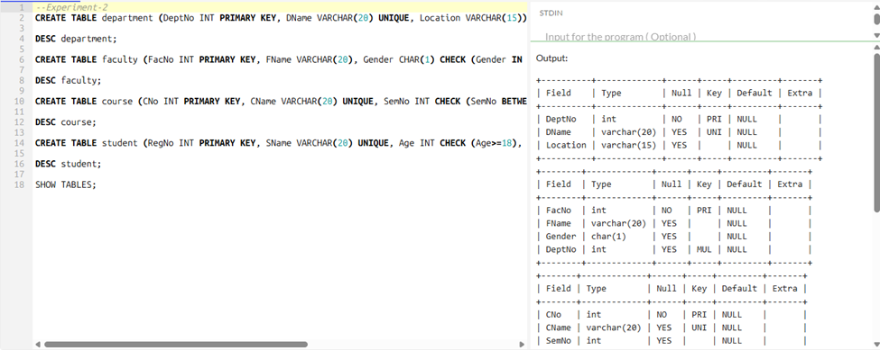

3) DML Commands – INSERT, SELECT, UPDATE, DELETE

CREATE DATABASE lab3;
USE lab3;

CREATE TABLE department(
deptno INT PRIMARY KEY,
dname VARCHAR(20),
hod VARCHAR(20)
);

CREATE TABLE faculty(
facno INT PRIMARY KEY,
fname VARCHAR(20),
gender CHAR(1),
mobileno BIGINT,
doj DATE,
deptno INT,
FOREIGN KEY (deptno) REFERENCES department(deptno)
);

CREATE TABLE student2(
RegNo INT PRIMARY KEY,
SName VARCHAR(20),
Age INT,
MobileNo BIGINT,
Facno INT,
FOREIGN KEY (Facno) REFERENCES faculty(facno)
);

INSERT INTO department VALUES
(1,'CSE','Ravi'),
(2,'ECE','Sita');

SELECT * FROM department;

INSERT INTO faculty VALUES
(101,'Anil','M',9876543210,'2020-06-01',1),
(102,'Kavya','F',9876501234,'2021-01-10',2);

SELECT * FROM faculty;

INSERT INTO student2 VALUES
(1,'Manoj',20,9876500001,101),
(2,'Ramesh',21,9876500002,102);

SELECT * FROM student2;

UPDATE student2 SET Age=22 WHERE RegNo=1;
SELECT * FROM student2;

DELETE FROM student2 WHERE RegNo=2;
SELECT * FROM student2;

OUTPUT:

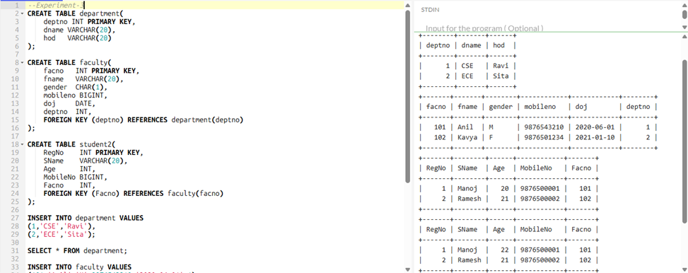

4) SELECT with various clause – WHERE, pattern matching

CREATE DATABASE lab4;
USE lab4;

CREATE TABLE student(
RegNo INT,
SName VARCHAR(20),
Age INT,
Branch VARCHAR(10)
);

INSERT INTO student VALUES
(1,'Ravi',20,'CSE'),
(2,'Kavya',21,'ECE'),
(3,'Ramesh',22,'CSE'),
(4,'Manoj',20,'EEE'),
(5,'Sita',21,'CSE');

-- Queries
SELECT * FROM student;
SELECT * FROM student WHERE Age=20;
SELECT * FROM student WHERE Branch='CSE';
SELECT * FROM student WHERE Age>20;
SELECT * FROM student WHERE Branch!='ECE';
SELECT * FROM student WHERE SName LIKE 'R%';
SELECT * FROM student WHERE SName LIKE '%a';
SELECT * FROM student WHERE SName LIKE '_a%';
SELECT * FROM student WHERE Branch IN ('CSE','EEE');
SELECT * FROM student WHERE Age BETWEEN 20 AND 21;

OUTPUT:

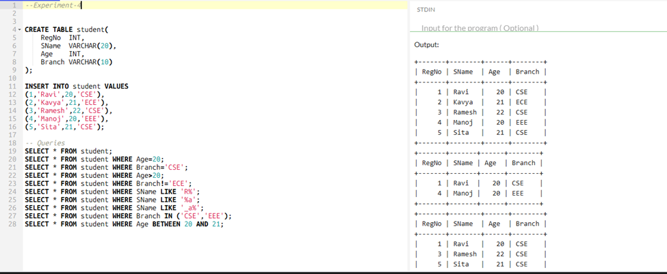

5) SELECT with various clause – BETWEEN, IN, Aggregate Function

CREATE DATABASE lab5;
USE lab5;

CREATE TABLE employee(
EmpNo INT,
EName VARCHAR(20),
Salary INT,
DeptNo INT
);

INSERT INTO employee VALUES
(1,'Ravi',30000,10),
(2,'Kavya',40000,20),
(3,'Manoj',25000,10),
(4,'Sita',50000,30),
(5,'Ramesh',45000,20);

-- Queries
SELECT * FROM employee;
SELECT * FROM employee WHERE Salary BETWEEN 30000 AND 50000;
SELECT * FROM employee WHERE DeptNo IN (10,30);
SELECT COUNT(*) FROM employee;
SELECT MAX(Salary) FROM employee;
SELECT MIN(Salary) FROM employee;
SELECT AVG(Salary) FROM employee;
SELECT SUM(Salary) FROM employee;

OUTPUT:
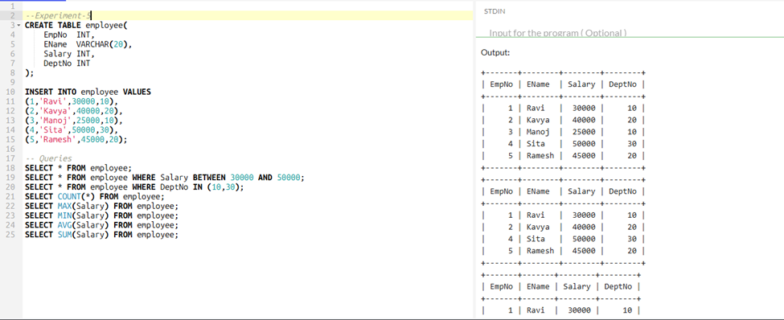

6) SELECT with various clause – GROUP BY, HAVING, ORDERBY

CREATE DATABASE lab6;
USE lab6;

CREATE TABLE sales(
SaleID INT,
Product VARCHAR(20),
Quantity INT,
Price INT
);

INSERT INTO sales VALUES
(1,'Pen',10,5),
(2,'Book',5,50),
(3,'Pen',20,5),
(4,'Pencil',15,3),
(5,'Book',10,50),
(6,'Pen',5,5);

-- Queries
SELECT * FROM sales;
SELECT Product, SUM(Quantity) FROM sales GROUP BY Product;
SELECT Product, SUM(Quantity) FROM sales GROUP BY Product HAVING SUM(Quantity) > 15;
SELECT * FROM sales ORDER BY Product;
SELECT * FROM sales ORDER BY Price DESC;

OUTPUT:
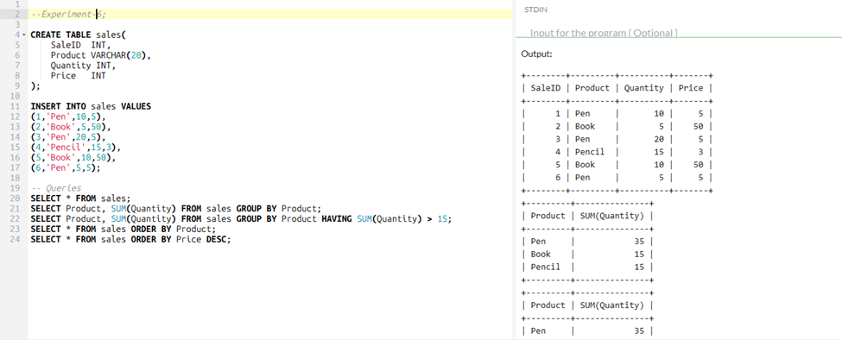

7) SubQuery& Correlated Query
CREATE DATABASE lab7;
USE lab7;

CREATE TABLE student(
SID INT,
SName VARCHAR(20),
Marks INT
);

INSERT INTO student VALUES
(1,'Ravi',85),
(2,'Kavya',92),
(3,'Manoj',76),
(4,'Sita',89);

SELECT * FROM student;

-- Subquery: Highest marks
SELECT SName, Marks
FROM student
WHERE Marks = (SELECT MAX(Marks) FROM student);

-- Correlated Query: Marks greater than overall average
SELECT S1.SName, S1.Marks
FROM student S1
WHERE S1.Marks > (
SELECT AVG(S2.Marks) FROM student S2
);

OUTPUT:
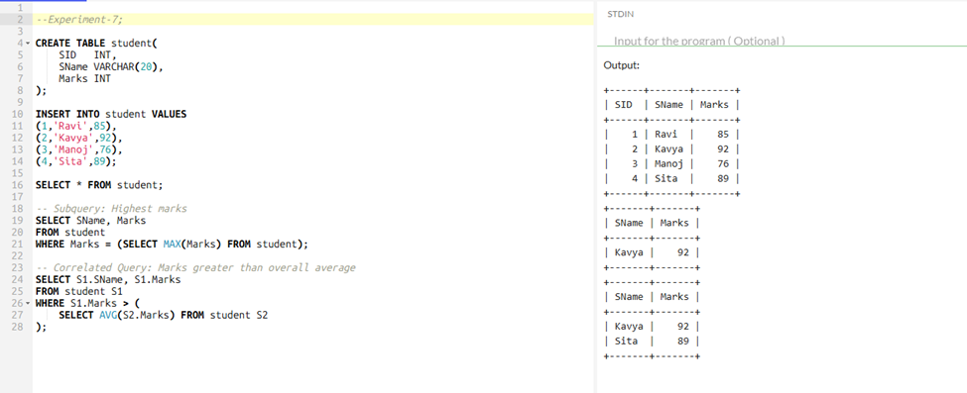

8) Joins – EquiJoin, InnerJoin, OuterJoin

CREATE DATABASE lab8;
USE lab8;

CREATE TABLE dept(
DeptNo INT,
DeptName VARCHAR(20)
);
INSERT INTO dept VALUES
(10,'CSE'),
(20,'ECE'),
(30,'EEE');

CREATE TABLE employee(
EmpNo INT,
EName VARCHAR(20),
DeptNo INT
);
INSERT INTO employee VALUES
(1,'Ravi',10),
(2,'Kavya',20),
(3,'Manoj',10),
(4,'Sita',40);

-- View all rows
SELECT * FROM dept;
SELECT * FROM employee;

-- Joins
SELECT e.EmpNo, e.EName, d.DeptName
FROM employee e, dept d
WHERE e.DeptNo = d.DeptNo;

SELECT e.EmpNo, e.EName, d.DeptName
FROM employee e
INNER JOIN dept d ON e.DeptNo = d.DeptNo;

SELECT e.EmpNo, e.EName, d.DeptName
FROM employee e
LEFT JOIN dept d ON e.DeptNo = d.DeptNo;

SELECT e.EmpNo, e.EName, d.DeptName
FROM employee e
RIGHT JOIN dept d ON e.DeptNo = d.DeptNo;

OUTPUT:
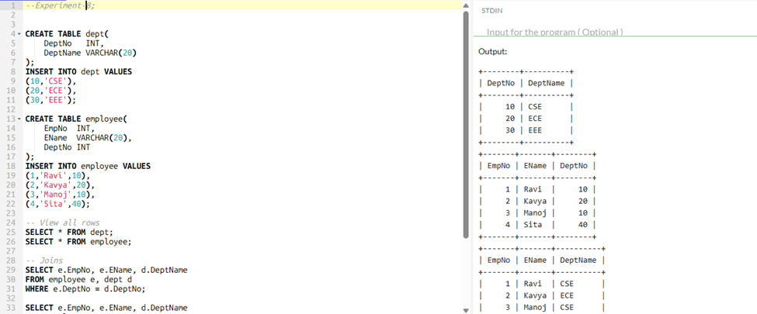

9) VIEW, INDEX, SEQUENCE
-- Create a sample database
CREATE DATABASE companyDB;
USE companyDB;

-- Create an employees table
CREATE TABLE employees (
EmpID INT PRIMARY KEY,
EmpName VARCHAR(50),
DeptName VARCHAR(30),
Salary INT
);

-- Insert some sample records
INSERT INTO employees VALUES
(1, 'Ravi', 'IT', 50000),
(2, 'Kavya', 'IT', 60000),
(3, 'Arun', 'HR', 40000),
(4, 'Divya', 'HR', 45000),
(5, 'Sita', 'Finance', 70000),
(6, 'Raj', 'Finance', 80000),
(7, 'Mohan', 'IT', 55000);

-- Example 1: GROUP BY (average salary by department)
SELECT DeptName, AVG(Salary) AS Avg_Salary
FROM employees
GROUP BY DeptName;

-- Example 2: GROUP BY with HAVING (departments with average salary > 55000)
SELECT DeptName, AVG(Salary) AS Avg_Salary
FROM employees
GROUP BY DeptName
HAVING AVG(Salary) > 55000;

-- Example 3: GROUP BY + HAVING + ORDER BY (highest average salaries first)
SELECT DeptName, AVG(Salary) AS Avg_Salary
FROM employees
GROUP BY DeptName
HAVING AVG(Salary) > 45000
ORDER BY Avg_Salary DESC;

OUTPUT:
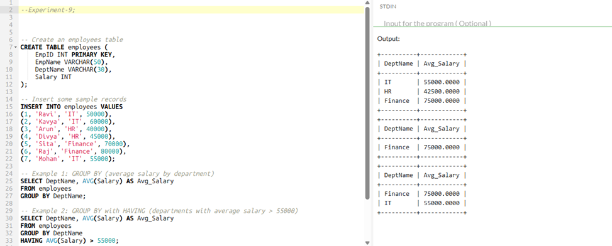

10) Simple programming exercises using CASE, IF, ITERATE, LEAVE, LOOP

-- Create database and table
CREATE DATABASE companyDB;
USE companyDB;

CREATE TABLE employees (
EmpID INT PRIMARY KEY,
EmpName VARCHAR(50),
DeptName VARCHAR(30),
Salary INT
);

-- Insert sample data
INSERT INTO employees VALUES
(1, 'Ravi', 'IT', 50000),
(2, 'Kavya', 'IT', 60000),
(3, 'Arun', 'HR', 40000),
(4, 'Divya', 'HR', 45000),
(5, 'Sita', 'Finance', 70000),
(6, 'Raj', 'Finance', 80000),
(7, 'Mohan', 'IT', 55000);

-- 🔹 Subquery: Employees earning more than company average salary
SELECT EmpName, DeptName, Salary
FROM employees
WHERE Salary > (SELECT AVG(Salary) FROM employees);

-- 🔹 Correlated Subquery: Employees earning more than
-- the average salary of their own department
SELECT EmpName, DeptName, Salary
FROM employees e1
WHERE Salary > (
SELECT AVG(Salary)
FROM employees e2
WHERE e1.DeptName = e2.DeptName
);

OUTPUT:
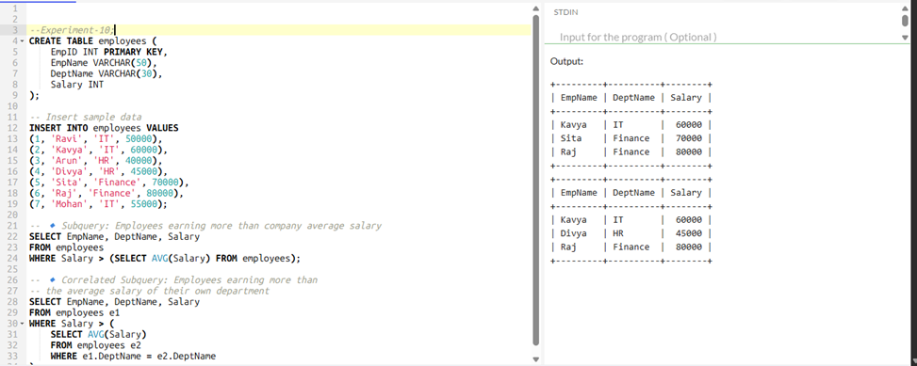

11) Simple programming exercises using REPEAT, WHILE

-- Drop old database if it already exists (prevents duplicate errors)
DROP DATABASE IF EXISTS companyDB;

-- Create fresh database
CREATE DATABASE companyDB;
USE companyDB;

-- Create Department table first (important for foreign key reference)
CREATE TABLE department (
DeptID INT PRIMARY KEY,
DeptName VARCHAR(30)
);

-- Create Employees table
CREATE TABLE employees (
EmpID INT PRIMARY KEY,
EmpName VARCHAR(50),
DeptID INT,
Salary INT,
FOREIGN KEY (DeptID) REFERENCES department(DeptID)
);

-- Insert Department data
INSERT INTO department (DeptID, DeptName) VALUES
(10, 'IT'),
(20, 'HR'),
(30, 'Finance'),
(40, 'Marketing');

-- Insert Employees data
INSERT INTO employees (EmpID, EmpName, DeptID, Salary) VALUES
(1, 'Ravi', 10, 50000),
(2, 'Kavya', 10, 60000),
(3, 'Arun', 20, 40000),
(4, 'Divya', 20, 45000),
(5, 'Sita', 30, 70000),
(6, 'Raj', 30, 80000),
(7, 'Mohan', 10, 55000);

-- ================================
-- 🔹 Equi Join
-- ================================
SELECT e.EmpName, e.Salary, d.DeptName
FROM employees e, department d
WHERE e.DeptID = d.DeptID;

-- 🔹 Inner Join
SELECT e.EmpName, e.Salary, d.DeptName
FROM employees e
INNER JOIN department d
ON e.DeptID = d.DeptID;

-- 🔹 Left Outer Join
SELECT e.EmpName, e.Salary, d.DeptName
FROM employees e
LEFT JOIN department d
ON e.DeptID = d.DeptID;

-- 🔹 Right Outer Join
SELECT e.EmpName, e.Salary, d.DeptName
FROM employees e
RIGHT JOIN department d
ON e.DeptID = d.DeptID;

OUTPUT:
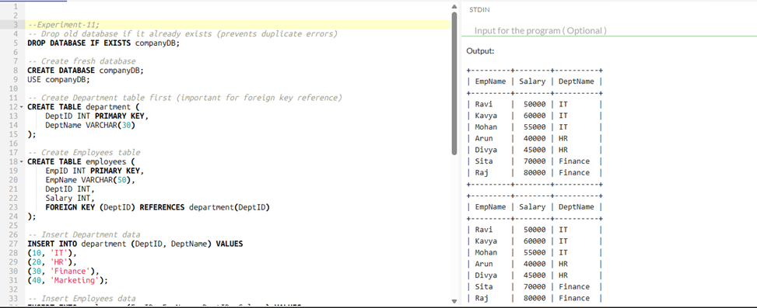

12) TCL Commands – COMMIT, ROLLBACK, SAVEPOINT
-- Drop and create fresh database
DROP DATABASE IF EXISTS companyDB;
CREATE DATABASE companyDB;
USE companyDB;

-- Create Department table
CREATE TABLE department (
DeptID INT PRIMARY KEY,
DeptName VARCHAR(30)
);

-- Create Employees table
CREATE TABLE employees (
EmpID INT PRIMARY KEY,
EmpName VARCHAR(50),
DeptID INT,
Salary INT,
FOREIGN KEY (DeptID) REFERENCES department(DeptID)
);

-- Insert Departments
INSERT INTO department VALUES
(10, 'IT'),
(20, 'HR'),
(30, 'Finance'),
(40, 'Marketing');

-- Insert Employees
INSERT INTO employees VALUES
(1, 'Ravi', 10, 50000),
(2, 'Kavya', 10, 60000),
(3, 'Arun', 20, 40000),
(4, 'Divya', 20, 45000),
(5, 'Sita', 30, 70000),
(6, 'Raj', 30, 80000),
(7, 'Mohan', 10, 55000);

-- =========================
-- 🔹 Create VIEW + Use it
-- =========================
CREATE VIEW emp_dept_view AS
SELECT e.EmpID, e.EmpName, e.Salary, d.DeptName
FROM employees e
INNER JOIN department d ON e.DeptID = d.DeptID;

-- Query the view
SELECT * FROM emp_dept_view;

-- =========================
-- 🔹 Create INDEX + Use it
-- =========================
CREATE INDEX idx_salary ON employees(Salary);

-- Query that benefits from index
SELECT * FROM employees WHERE Salary > 60000;
OUTPUT:
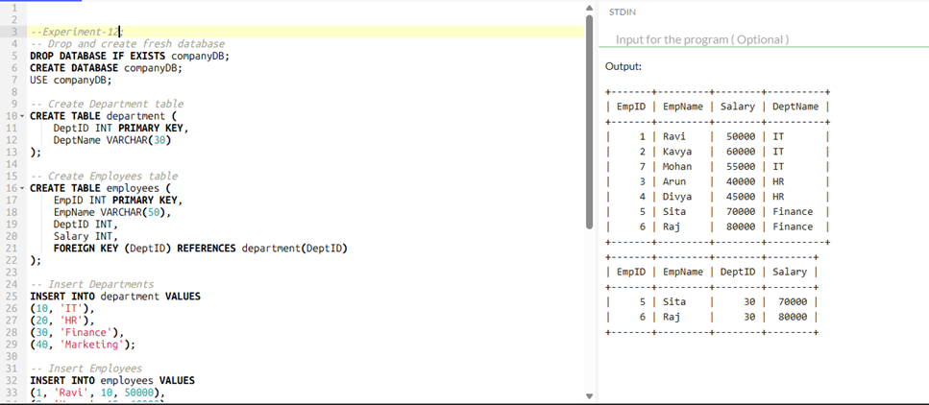

13) DCL Commands – GRANT, REVOKE

-- Drop and create fresh database
DROP DATABASE IF EXISTS companyDB;
CREATE DATABASE companyDB;
USE companyDB;

-- Create table with AUTO_INCREMENT
CREATE TABLE employees (
EmpID INT AUTO_INCREMENT PRIMARY KEY,
EmpName VARCHAR(50),
DeptName VARCHAR(30),
Salary INT
);

-- Insert employees (no need to give EmpID, it will auto-generate)
INSERT INTO employees (EmpName, DeptName, Salary) VALUES
('Ravi', 'IT', 50000),
('Kavya', 'IT', 60000),
('Arun', 'HR', 40000),
('Divya', 'HR', 45000),
('Sita', 'Finance', 70000),
('Raj', 'Finance', 80000);

-- View table data
SELECT * FROM employees;

-- Show how AUTO_INCREMENT continues
INSERT INTO employees (EmpName, DeptName, Salary) VALUES ('Mohan', 'IT', 55000);

SELECT * FROM employees;

-- =========================
-- Change AUTO_INCREMENT start value (optional)
-- =========================
ALTER TABLE employees AUTO_INCREMENT = 100;

-- Next insert will start from 100
INSERT INTO employees (EmpName, DeptName, Salary) VALUES ('Anu', 'Marketing', 65000);

SELECT * FROM employees;

OUTPUT:
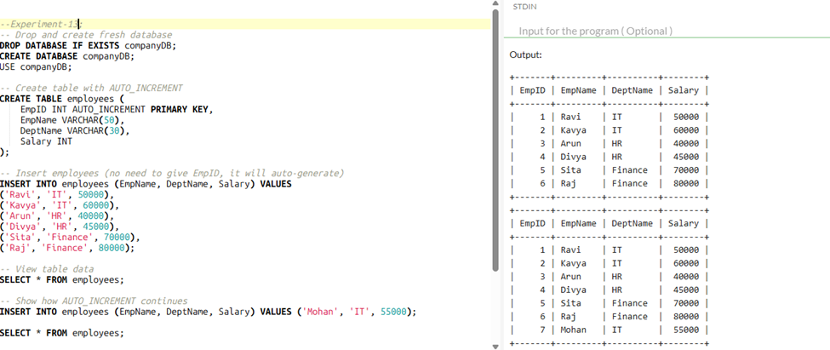

14) Procedures
-- Drop procedure if exists
DROP PROCEDURE IF EXISTS demo_loops;

DELIMITER $$

CREATE PROCEDURE demo_loops()
BEGIN
DECLARE i INT DEFAULT 1;
DECLARE j INT DEFAULT 1;

-- WHILE loop: Print numbers 1 to 5
SELECT 'WHILE loop output:' AS Info;
WHILE i <= 5 DO
SELECT i AS Number;
SET i = i + 1;
END WHILE;

-- REPEAT loop: Print numbers 6 to 10
SELECT 'REPEAT loop output:' AS Info;
REPEAT
SELECT j + 5 AS Number; -- start from 6
SET j = j + 1;
UNTIL j > 5
END REPEAT;
END$$

DELIMITER ;

-- Call the procedure
CALL demo_loops();

OUTPUT:

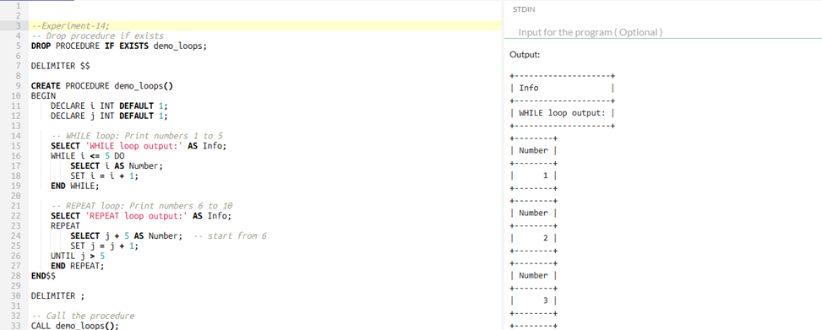
15) Function
-- Drop procedure if exists
DROP PROCEDURE IF EXISTS demo_case_loop;

DELIMITER $$

CREATE PROCEDURE demo_case_loop()
BEGIN
DECLARE i INT DEFAULT 1;

-- Label for LOOP
my_loop: LOOP
-- Use CASE to check value of i
CASE
WHEN i = 1 THEN SELECT 'i is 1' AS Info;
WHEN i = 2 THEN SELECT 'i is 2' AS Info;
WHEN i = 3 THEN SELECT 'i is 3' AS Info;
ELSE SELECT CONCAT('i is ', i) AS Info;
END CASE;

SET i = i + 1;

-- Exit loop when i > 5
IF i > 5 THEN
LEAVE my_loop;
END IF;
END LOOP my_loop;
END$$

DELIMITER ;

-- Call the procedure
CALL demo_case_loop();

OUTPUT:
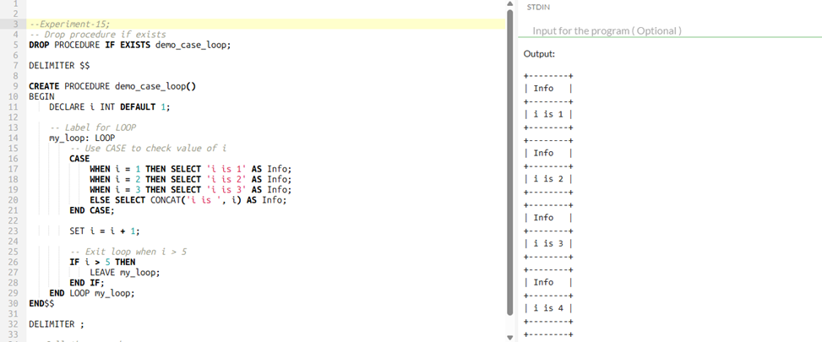

16) Cursors

-- Drop old database if exists
DROP DATABASE IF EXISTS companyDB;
CREATE DATABASE companyDB;
USE companyDB;

-- Create Employees table
CREATE TABLE employees (
EmpID INT AUTO_INCREMENT PRIMARY KEY,
EmpName VARCHAR(50),
DeptName VARCHAR(30),
Salary INT
);

-- Insert sample data
INSERT INTO employees (EmpName, DeptName, Salary) VALUES
('Ravi', 'IT', 50000),
('Kavya', 'IT', 60000),
('Arun', 'HR', 40000),
('Divya', 'HR', 45000),
('Sita', 'Finance', 70000),
('Raj', 'Finance', 80000),
('Mohan', 'IT', 55000);

-- ==================================
-- 🔹 Create Procedure: High-Level Example
-- ==================================
DROP PROCEDURE IF EXISTS employee_report;

DELIMITER $$

CREATE PROCEDURE employee_report(IN min_salary INT, OUT emp_count INT)
BEGIN
DECLARE i INT DEFAULT 1;
DECLARE total INT DEFAULT 0;
DECLARE max_emp INT;

SELECT COUNT(*) INTO max_emp FROM employees;

-- Loop through employees using counter
loop_emps: LOOP
IF i > max_emp THEN
LEAVE loop_emps;
END IF;

-- Display employee info using CASE for salary range
SELECT EmpID, EmpName, DeptName, Salary,
CASE
WHEN Salary < 50000 THEN 'Low'
WHEN Salary BETWEEN 50000 AND 70000 THEN 'Medium'
ELSE 'High'
END AS Salary_Range
FROM employees
WHERE EmpID = i;

-- Count employees with salary > min_salary
IF (SELECT Salary FROM employees WHERE EmpID = i) > min_salary THEN
SET total = total + 1;
END IF;

SET i = i + 1;
END LOOP loop_emps;

SET emp_count = total; -- set OUT parameter
END$$

DELIMITER ;

-- ==================================
-- 🔹 Call Procedure
-- ==================================
-- Declare variable to store OUT parameter
SET @count = 0;

-- Call procedure: find employees with salary > 55000
CALL employee_report(55000, @count);

-- Show number of employees with salary > 55000
SELECT @count AS Employees_Above_55000;

OUTPUT:
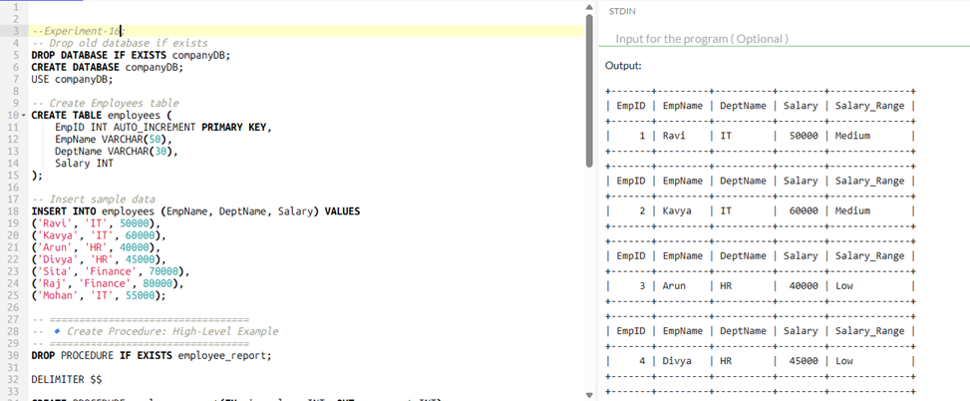
17) Triggers

-- Drop database if exists
DROP DATABASE IF EXISTS companyDB;
CREATE DATABASE companyDB;
USE companyDB;

-- Create Employees table
CREATE TABLE employees (
EmpID INT AUTO_INCREMENT PRIMARY KEY,
EmpName VARCHAR(50),
DeptName VARCHAR(30),
Salary INT
);

-- Insert sample data
INSERT INTO employees (EmpName, DeptName, Salary) VALUES
('Ravi', 'IT', 50000),
('Kavya', 'IT', 60000),
('Arun', 'HR', 40000),
('Divya', 'HR', 45000),
('Sita', 'Finance', 70000),
('Raj', 'Finance', 80000),
('Mohan', 'IT', 55000);

-- ==================================
-- 🔹 Create Function to categorize salary
-- ==================================
DROP FUNCTION IF EXISTS salary_category;

DELIMITER $$

CREATE FUNCTION salary_category(sal INT)
RETURNS VARCHAR(10)
DETERMINISTIC
BEGIN
DECLARE category VARCHAR(10);

CASE
WHEN sal < 50000 THEN SET category = 'Low';
WHEN sal BETWEEN 50000 AND 70000 THEN SET category = 'Medium';
ELSE SET category = 'High';
END CASE;

RETURN category;
END$$

DELIMITER ;

-- ==================================
-- 🔹 Stored Procedure: Loop through employees and use the function
-- ==================================
DROP PROCEDURE IF EXISTS employee_report_func;

DELIMITER $$

CREATE PROCEDURE employee_report_func(IN min_salary INT, OUT emp_count INT)
BEGIN
DECLARE i INT DEFAULT 1;
DECLARE total INT DEFAULT 0;
DECLARE max_emp INT;

SELECT COUNT(*) INTO max_emp FROM employees;

loop_emps: LOOP
IF i > max_emp THEN
LEAVE loop_emps;
END IF;

-- Display employee info using the function
SELECT EmpID, EmpName, DeptName, Salary, salary_category(Salary) AS Salary_Range
FROM employees
WHERE EmpID = i;

-- Count employees with salary > min_salary
IF (SELECT Salary FROM employees WHERE EmpID = i) > min_salary THEN
SET total = total + 1;
END IF;

SET i = i + 1;
END LOOP loop_emps;

SET emp_count = total; -- set OUT parameter
END$$

DELIMITER ;

-- ==================================
-- 🔹 Call Procedure
-- ==================================
SET @count = 0;
CALL employee_report_func(55000, @count);
-- Show number of employees with salary > 55000
SELECT @count AS Employees_Above_55000;
OUTPUT:
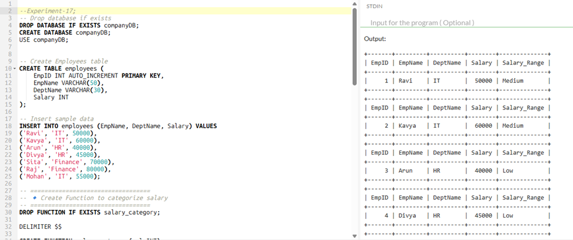

18) String Functions
-- Drop database if exists
DROP DATABASE IF EXISTS stringDB;
CREATE DATABASE stringDB;
USE stringDB;

-- Create sample table
CREATE TABLE sample_text (
ID INT AUTO_INCREMENT PRIMARY KEY,
Name VARCHAR(50),
TextField VARCHAR(100)
);

-- Insert sample data
INSERT INTO sample_text (Name, TextField) VALUES
('Ravi', 'Hello World'),
('Kavya', 'MySQL Tutorial'),
('Arun', 'Database Functions');

-- ==========================================
-- 🔹 Single Query Demonstrating All String Functions
-- ==========================================
SELECT
Name,
TextField,
-- Replace "World" with "MySQL"
REPLACE(TextField, 'World', 'MySQL') AS ReplacedText,
-- Repeat "Hi " three times
REPEAT('Hi ', 3) AS RepeatedText,
-- Reverse the string
REVERSE(TextField) AS ReversedText,
-- Get last 5 characters
RIGHT(TextField, 5) AS RightText,
-- Get first 5 characters
LEFT(TextField, 5) AS LeftText,
-- Right pad Name to length 10 with "*"
RPAD(Name, 10, '*') AS RightPadded,
-- Left pad Name to length 10 with "-"
LPAD(Name, 10, '-') AS LeftPadded
FROM sample_text;

OUTPUT:
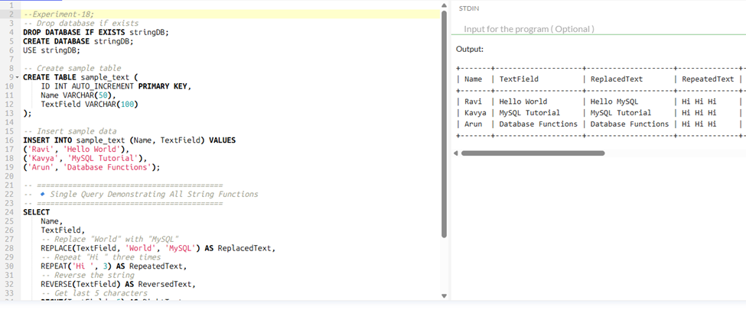

19) String Functions
-- Drop database if exists
DROP DATABASE IF EXISTS stringDB;
CREATE DATABASE stringDB;
USE stringDB;

-- Create sample table
CREATE TABLE sample_text (
ID INT AUTO_INCREMENT PRIMARY KEY,
Name VARCHAR(50),
TextField VARCHAR(100)
);

-- Insert sample data
INSERT INTO sample_text (Name, TextField) VALUES
('Ravi', ' Hello World '),
('Kavya', ' MySQL Tutorial '),
('Arun', ' Database Functions ');

-- ==========================================
-- 🔹 Single Query Demonstrating All Functions
-- ==========================================
SELECT
Name,
TextField,
-- SPACE(n): returns n spaces
CONCAT(Name, SPACE(5), 'X') AS NameWithSpaces,
-- SUBSTR(str, start, length): extract substring
SUBSTR(TextField, 4, 5) AS SubStringText,
-- UPPER: convert string to uppercase
UPPER(TextField) AS UpperText,
-- LOWER: convert string to lowercase
LOWER(TextField) AS LowerText,
-- TRIM: remove leading and trailing spaces
TRIM(TextField) AS TrimmedText,
-- LENGTH: number of characters including spaces
LENGTH(TextField) AS TextLength
FROM sample_text;

OUTPUT:
